A Further Study of Metropolis Monte Carlo Simulation of Br Atoms on Cu Surface

(Research Report for UROP Project, Fall 2013)

Shen CHEN, N. Lin (Supervisor)

Department of Physics

HKUST

Hong Kong

schenad@stu.ust.hk

*This project is a continuation of my summer project, which is simulating the behavior of Br atoms on Cu surface using Metropolis Monte Carlo algorithm developed by Nicholas Metropolis et al. [1]. In this project, the remained problem in the summer project is solved. The value of bonding energy and repulsion energy was determined so that the size distribution, the shape distribution and the pair correlation function of the Br islands in the simulation could consist with the experimental results. Furthermore, the model was used to study how the heat capacity of this system related to the temperature, and phase change was observed in this simulation model when the temperature was rising.*

Keywords—Metropolis Monte Carlo algorithm, Br atoms, Cu (111) surface, heat capacity

# Introduction

The experiment part of this project is operated by Shiyong Wang, who was a graduated PG student in HKUST. In his experiment, the Br atoms were initially randomly distributed on the Cu (111) surface at about 300K while the sample started to be cooled down. When the temperature came to 50K, the moving of Br atoms on the Cu (111) surface slowed down and some localized islands were formed. As the temperature reached to 5K, the atoms seem to be “frozen” under the STM and the steady islands were formed (Fig. 1) with very few single Br atoms on the Cu surface.

To study the phenomenon, Metropolis Monte Carlo algorithm was being used in programming and a model that could somehow simulate this system was built. To characterize the Br islands, the size distribution, the shape distribution and the pair correlation function of these islands have been studied. By compare these three characters of the Br islands in experimental results and the simulation results, the correctness of the simulation model could be verified. Therefore, the model can be used to explain, or even predict the experiments.

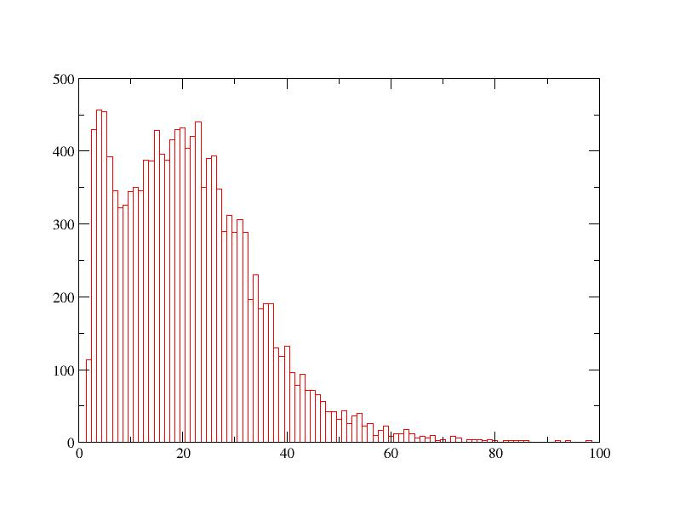

(1)

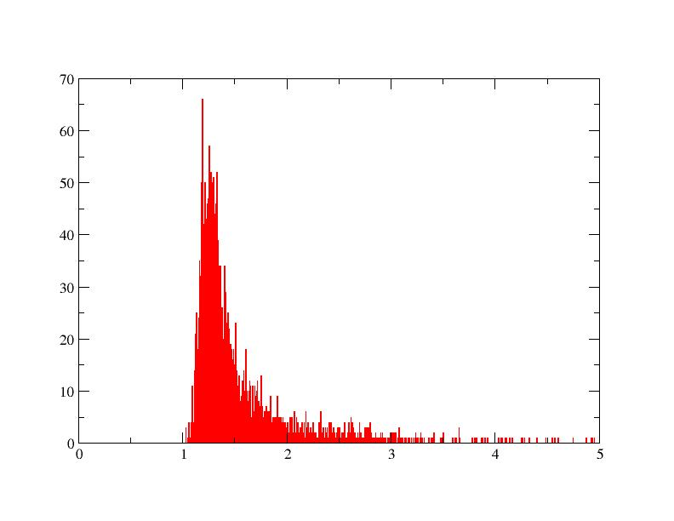

(2)

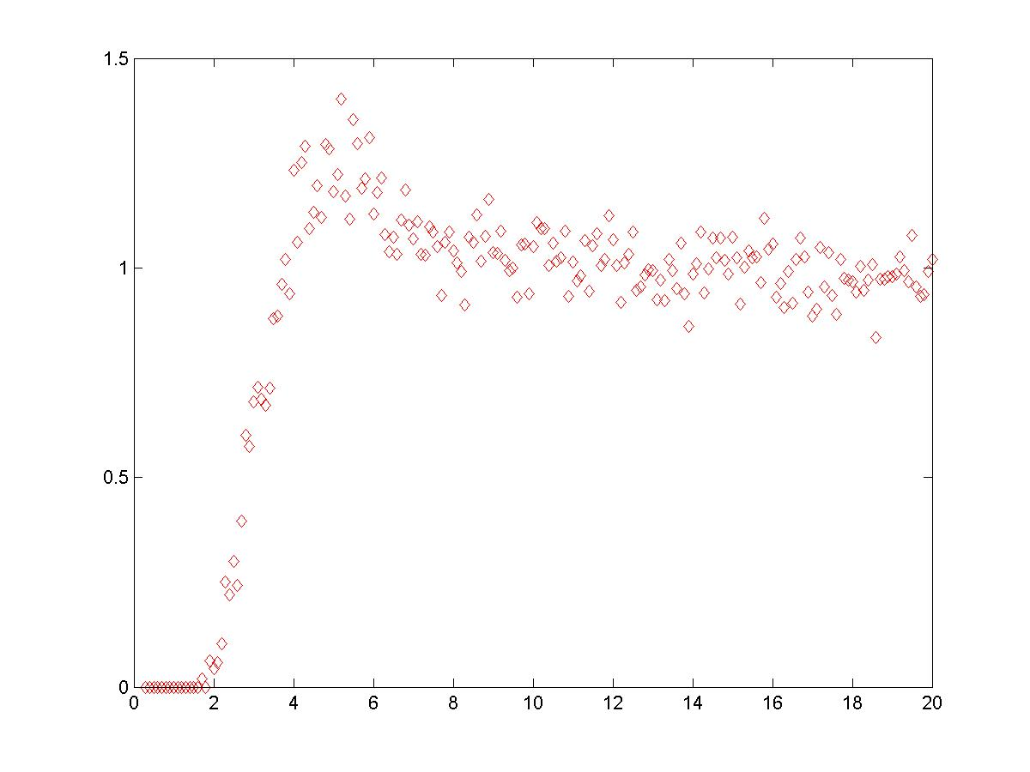

(3)

Fig. 2. Size distribution (1), shape distribution (2) and pair correlation function (3) of the experimental Br islands in the system with the low coverage (0.1092 ML).

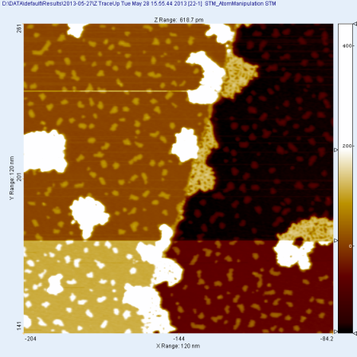Fig. 1. STM image of the Br islands on Cu surface. The large white speckles are molecules; the small ones are Br islands

# Characterization of the experimental results

By analyzing the experimental data, some character of the Br islands in the experiment could be observed. As already being discussed in the summer project report, there are three cases, which are low coverage (0.1092ML), medium coverage (0.3365ML) and high coverage (0.7195ML) of Br atoms on the Cu surface. Fig. 2 shows the main character of the Br islands, which are Size distribution (1), shape distribution (2) and pair correlation function (3). The size of a Br island is defined by the number of the Br atoms in this island, i.e., if the island consists of 3 Br atoms, the size of the island is 3. The shape of a Br island is defined by the square of perimeter divided by the size of island, and it is defined that the single atom (island with size 1) has shape parameter equals to 1. The definition of pair correlation function is the same as the common one, and the unit on the x-axis is nm. In Fig. 2, one could observed that the peak of size distribution is at about 21, which means the most

| Coverage | Size distribution | Pair correlation function |
| --- | --- | --- |
| 0.1092ML | 21 | 5 |
| 0.3365ML | 30 | 4.75 |
| 0.7195ML | 14 | 4 |

1. peak position of different character of br islands under differnent converage

common Br islands are the ones consist of around 21 atoms. Since the shape distribution is not so accurate, it was abandoned. Table 1 summarized the peak position of different island character. Especially, for the high coverage (0.7195ML), since most of the plane is covered by the Br atoms, the observed objects become holes (areas without Br atoms) instead of Br islands. (Actually, only one large Br islands with many small holes on it will be observed in this case.)

# steps of simulation

## Modeling

A 200200 triangular grid graph is used in this simulation as the “lattice”. It is defined that “Br atoms” can only move among the lattice points. In each step, one atom that is randomly chosen will be moved (as “a step”) and ∆E, which is the difference between the system energy before and after moving, will be calculated. Whether accept this step will depend on the result of ∆𝐸, which is defined by equation (1):

(1) where is the bonding energy of one bond between adjacent atoms, is number of bonds formed around the chosen atom, A is a constant and r is the distance between the chosen atom and any other atoms on the lattice. If ∆E ≤ 0, the possibility to accept the step is 100%, otherwise, the possibility to accept the step should be the Boltzmann factor. The temperature was set to be 5 K, which is the same as the experiment condition.

## The number of operating steps

Since the system should reach its lowest energy state in the experiment by annealing, to determine the smallest number of “steps” that could make the simulation model reach its minimum energy state, the change of ∆E was studied. As shown in the Fig.3, ∆E goes to about 0 after 106 steps, which implies that the system reaches a stable state with minimum energy after about 106 step. In practice, the step was set to be 5106 to ensure the system really reaching the final stable state with lowest energy.

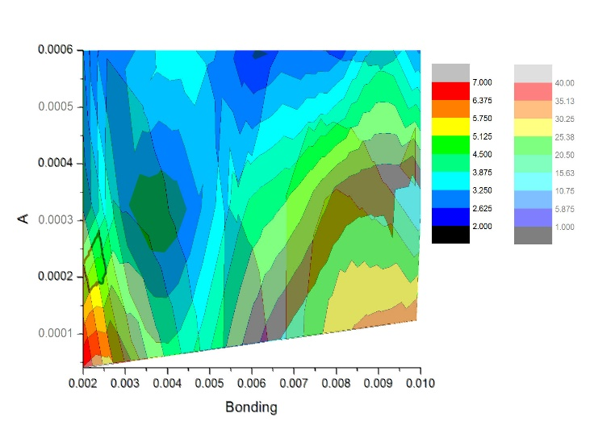

Fig. 4. Contour plot of the peak position of size distribution (lighter) and pair correlation function (darker) of the case with 0.1092ML Br atoms under different bonding energy (x-axis) and different repulsion constant A (y-axis).

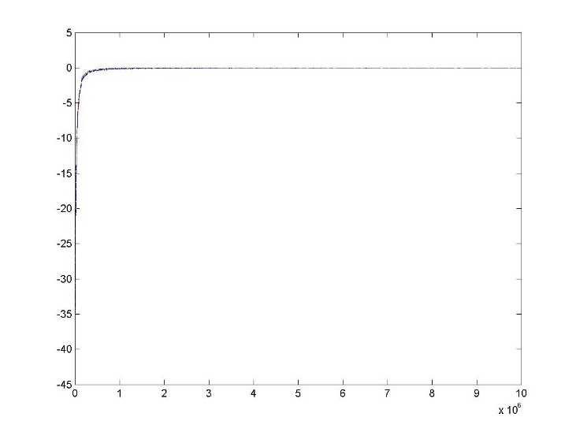

Fig. 3. ∆E vs steps, where y-axis is the value of ∆E every 10000 steps, x-axis is the steps have operated.

## Simulation Results

There are still two constant to be determined for the simulation model, which are the bonding energy EB and the constant A of the repulsive energy. To work out these two constant, many sets of EB and A were tried. To narrow down the possible area that the real value of EB and A would appear, the contour plot of the results was used, as shown in Fig. 4. By finding the comparable peak position as shown in Table 1, the range of EB and A could be determined.

Actually, referring to equation (1), and Boltzmann factor, the whole system could also be determined by the temperature and the proportion EB : A. Rising the temperature for n times will have the same effect as rising EB and A for n times simultaneously. Therefore, it is nature that if the proportion is fixed, the final results will be similar.to each other under different temperature.

However, it is only true in some cases that temperature is relatively high (or bonding energy is relatively low). That is because if the temperature is too low, the energy of the system will drop into a local minimum shown in Fig. 5 and failed to get out since the term in is too large and it makes the accept rate too low to “climb” over the local minimum. To solve the problem, a larger T or a smaller bonding energy could be set, but if the temperature is too high or the bonding energy is too low, the islands would be unstable. Although it ensures the system climbs over the local minimum, but the fluctuation will be too large to limit the system in the global minimum, and many single atoms will appear on the plane with the unstable islands, which is different from the situation to be simulated. Therefore, it will be nice to find a bonding energy which is large enough to let the system climb over the local minimum, and smaller enough to make the system has stable islands. And it should have the same peak position of size distribution and pair correlation function of the Br islands in the simulation model as got in the experiment.

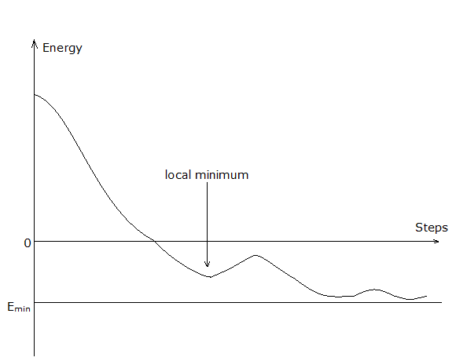

Fig. 5. The imaginary energy curve of the simulation model.

Under the temperature=5K, finally, it was found that with the bonding energy EB=0.00225eV, A=4E-4, the simulation results have the same size distribution and pair correlation function as the experimental result, which is shown in Fig. 6. Since the Br islands start to become stable at about 50K, which is 10 times of 5K, the real value of EB and A should be about EB=0.0225eV and A=4E-3 respective according to the previous discussion.

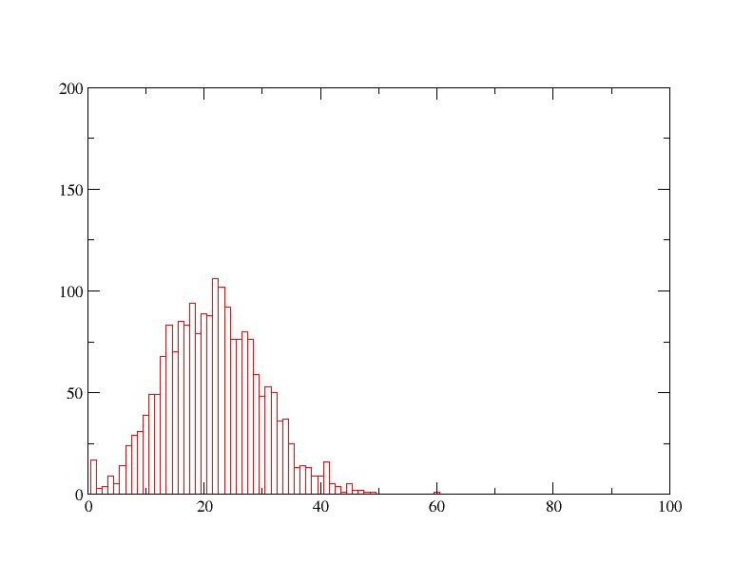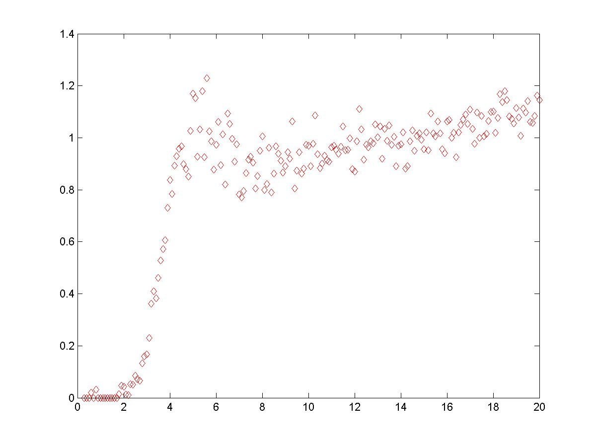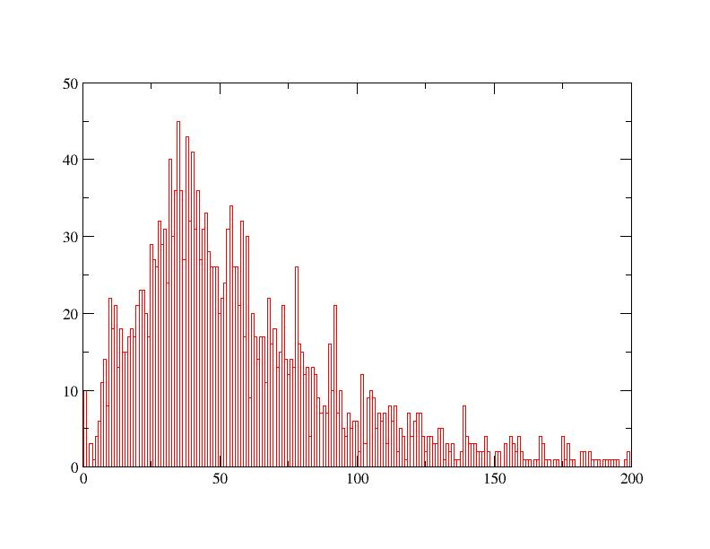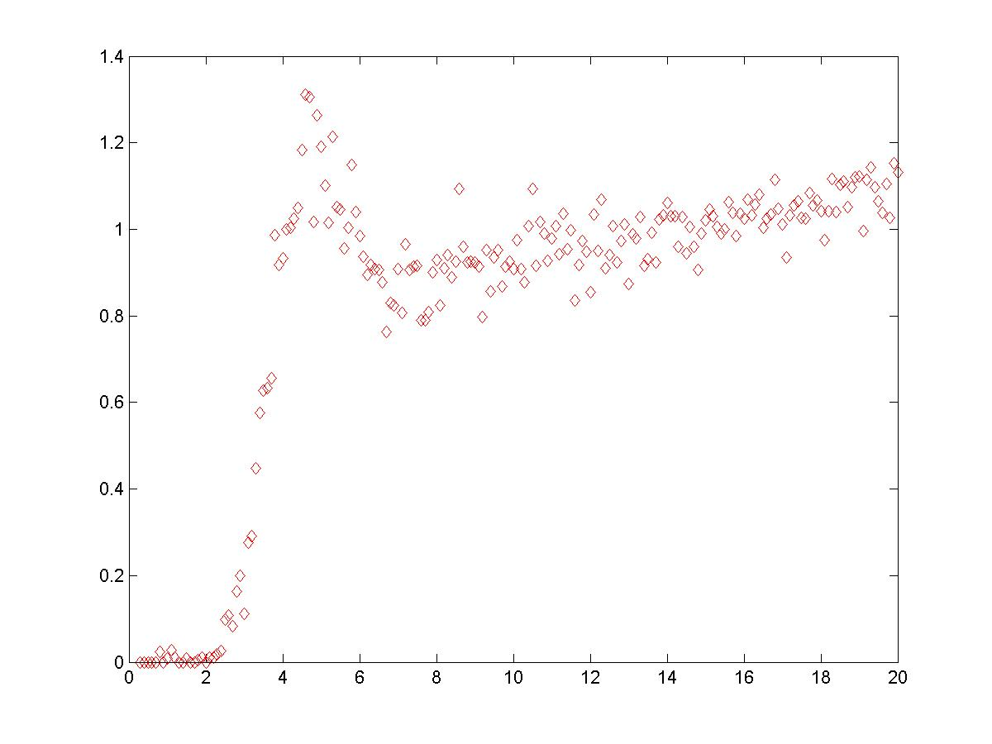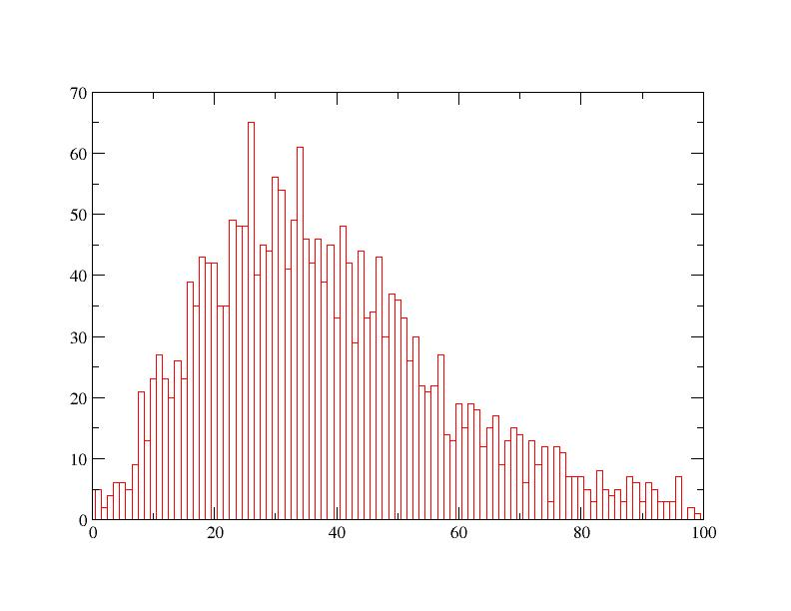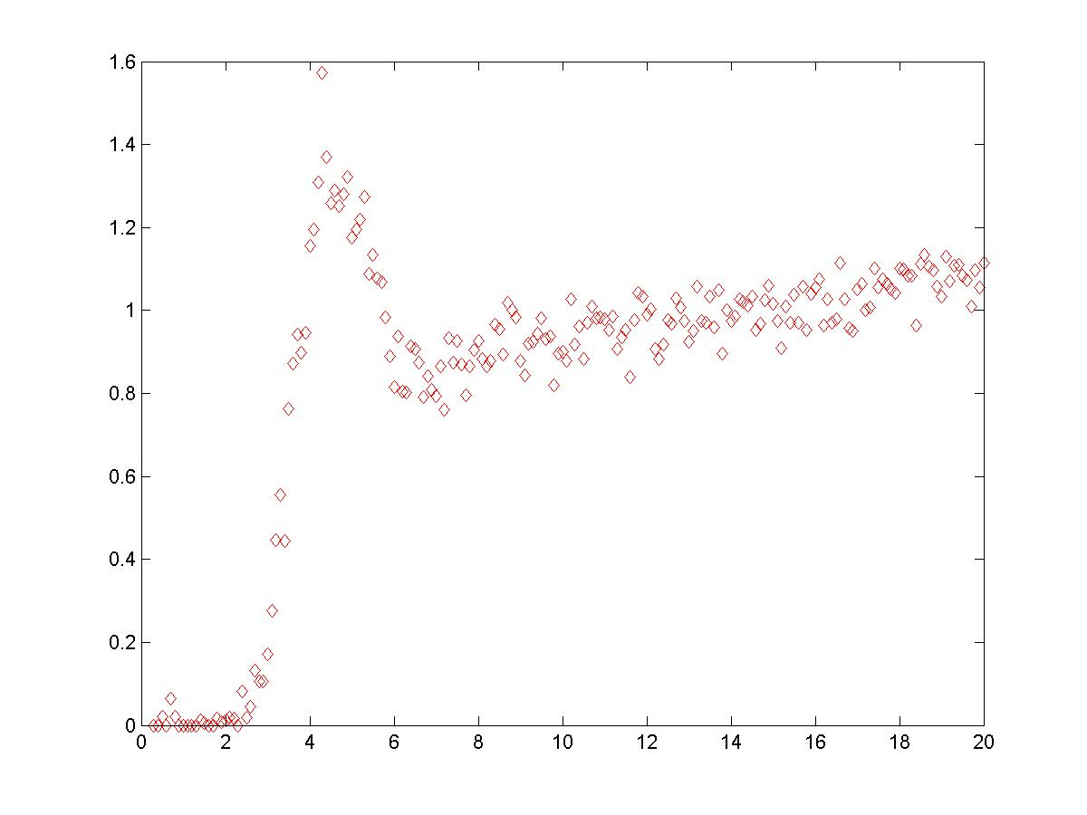

Fig. 6. The size distribution and pair correlation function for the Br islands with EB= 0.00225eV, A=4E-4 for three coverages.

# Study of heat capacity in the system

After all the constant for the model is decided, it will be possible to simulate the system under different temperature and find some properties of this simulation model.

The property that is chosen to study is heat capacity Cv. There are two ways to calculate the Cv. One way is using the formula , where E is the total energy of the system, kB is the Boltzmann constant, T is the temperature. The other way is directly differentiate the E (T) and . In practice, the later one has more stable results.

The total energy consists of bonding energy, repulsive energy and the kinetic energy, which is calculated by KE=NkBT, where N is the number of free atoms with no bond. To simplify the problem, the model without repulsion is tried.

## Heat Capacity of the model without repulsion

For a low coverage with coverage=0.01ML, a peak was observed in the Cv-T diagram (Fig. 8), and the phase change appears near the peak, which is at about 14 K as shown in Fig. 7, which verified the observation in the Cv-T diagram.

Fig. 9. shows how the Cv-T diagram changes under different coverages. All the peaks are quite sharp, which implies that the phase changes happened.

## Heat Capacity of the model with repulsion

After adding the repulsion, the Cv-T diagram become quite different from the one observed in the case without repulsion.

Fig. 9. The Cv-T diagram of the system with EB= 0.00225eV, A=0 under different coverage.

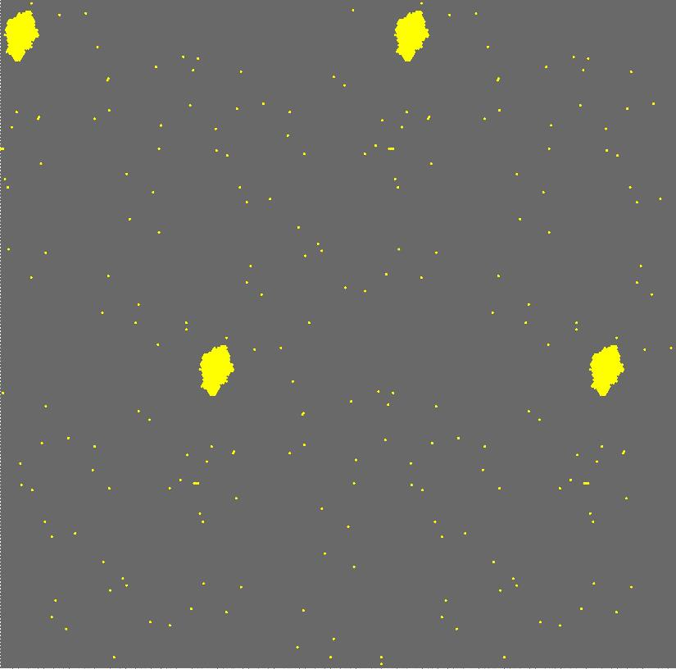  

12K 13K 14K

 

15K 16K

Fig. 7. The phase change of the system with coverage = 0.01ML, EB= 0.00225eV, A=0

Fig. 8. The Cv-T diagram of the system with coverage = 0.01ML, EB= 0.00225eV, A=0

From Fig. 10., one could observed that the phase change is happened gradually as the temperature is rising, which is corresponding to the broad peak on the Cv-T diagram

Fig. 11. The Cv-T diagram of the system with EB= 0.00225eV, A=4E-4 under different coverage.

 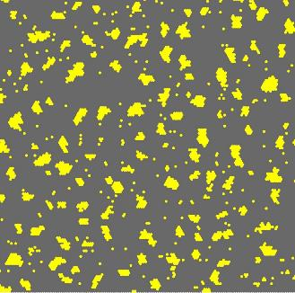 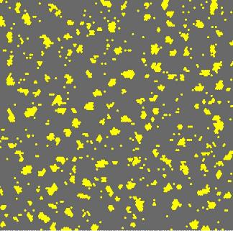

10K 11K 12K

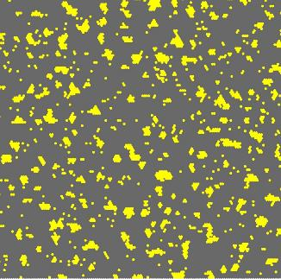 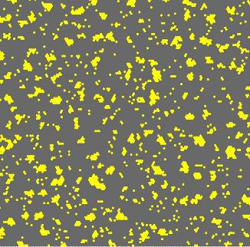

13K 14K

Fig. 10. The phase change of the system with coverage = 0.1092ML, EB= 0.00225eV, A=4E-4

Fig. 11. The Cv-T diagram of the system with coverage = 0.1092ML, EB= 0.00225eV, A=4E-4

From the Cv-T diagrams shown in the Fig.11., the phase change point of this system could be approximately determined by finding the peak of Cv curve, and the thermal dynamic property of this system could be found in this way.

# conclusion

In this project, the value of bonding energy EB and constant A in repulsion has been found. Moreover, the heat capacity of this system was studied, under the condition without or with the repulsion, and the different thermal dynamic property of these two systems is observed.

##### Acknowledgment

I would like to thank Tao Lin and Shiyong Wang for the experiment data, their Matlab program to calculate the coverage, the pair correlation function, and their assistance of programing.

##### References

1. Metropolis, N.; Rosenbluth, A.W.; Rosenbluth, M.N.; Teller, A.H.; Teller, E. (1953). "Equations of State Calculations by Fast Computing Machines". *Journal of Chemical Physics* **21** (6): 1087–1092.

**Appendix**

The programming languages that have been used are C++ and Matlab. The C++ program should be compiled and run under Linux and the host I used is “stu.phys.ust.hk”. Here are programs written for completing the project, and it may cause some time to figure out how to use these programs. Therefore I wrote a brief introduction to these programs:

The main program is. Since the output files are separated txt files, is needed to combine these files.

The program can read the simulation data and count for the size and number of islands. By using the tool “xmgrace” in Linux, one can get the size distribution and shape distribution of the islands.

The program can read the simulation data and convert it into the pictures. Then we can useto analyze these pictures and finally get the pair correlation function of the Br islands.

is used for calculating the heat capacity. By inputting a temperature, it could operate MC steps under this temperature and finally output the total energy of this system, and the final state.